**Topic:** Over the century: Can we help fishing cat (*Prionailurus viverrinus*) survive in the human dominated landscape

**Species:** Fishing Cat (*Prionailurus viverrinus*) (FC) (IUCN status: Vulnerable)

**Study area:** Khao Sam Roi Yot National Park (12°10′57″N 99°56′54″E, 98 km2) is situated in the South-west of Thailand. The land-use types consist of: (1) traditional aquaculture pond, (2) agriculture, (3) abandoned area, (4) natural forest, (5) human settlement areas, and (6) non-habitat areas.

**Problem:** The human-FC conflict and land-use change can affect FC’s survival and resulting local extinction.

**Objective:** How can we resolve the threats to increase the survival rate of FC

**Develop Alternatives:** In this stage, we used the Structured Decision Making (SDM) to help making the decision, which generated the scenarios of resolving (Fig. 1) the method and choose the best scenario to implement in the area.

**Estimate Consequences:** We have 4 scenarios, and we used the Bayesian Belief Network (Fig. 2) to estimate the uncertainty of each scenario dataset, which indicate in the effectiveness value.

**Evaluate Trade-Offs and Select:** We evaluated the scenarios and found that the best scenario is scenario 1 (Fig. 1) which is the highest of effectiveness value.

**Implement and Monitor:** We have implemented the best scenario in the area and monitoring to assess the effectiveness by using the occupancy and spatially explicit capture-recapture (secr) every 5 years in three seasons.

**How fishing cat survive over the century:** We generated the demographic data by using the occupancy and secr model to calculate the survival rate and fit those data in the Population viability analysis (PVA) model and predict the extinction rate over the 100 years.

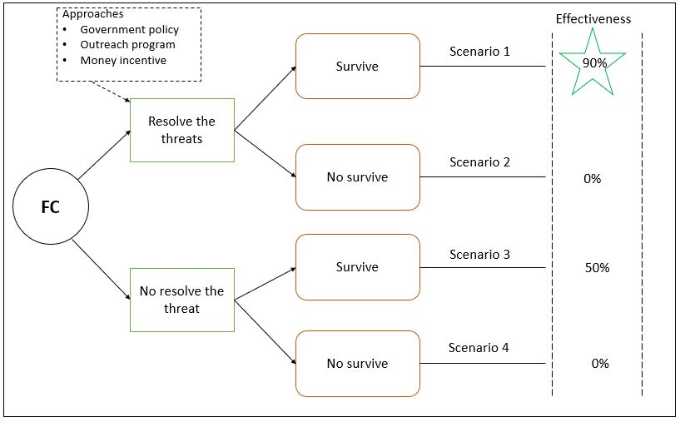

Figure 1. A decision tree showing the scenarios to implement and monitoring action.

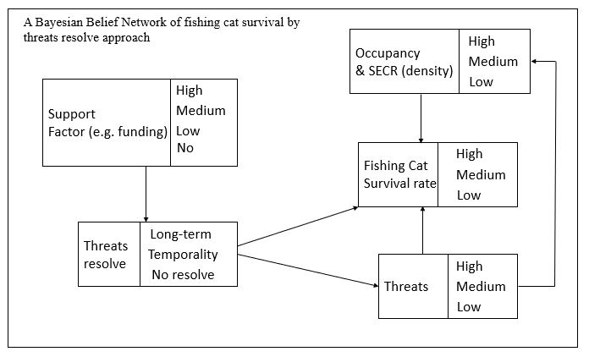Figure 2. A Bayesian Belief Network of fishing cat survival by threats resolve approach